A Research Use Only Content Guide for ALK, ROS1, RET, NTRK1, HER2 and cMET Data Generated from the   
HTG EdgeSeq ALK*Plus* Assay EU

**Introduction**

Using a single slide, the HTG EdgeSeq ALK*Plus* Assay EU (“Assay”) consolidates complex molecular testing into a single platform and provides additional research data on potential therapeutic targets. The HTG EdgeSeq ALK*Plus* Assay EU is an *in vitro* diagnostic (IVD), next-generation sequencing (NGS)-based assay intended to measure and analyze mRNA ALK gene fusion events in formalin-fixed, paraffin-embedded (FFPE) lung tumor specimens from patients previously diagnosed with non-small cell lung cancer (NSCLC). In addition, the Assay can measure certain mRNA targets from FFPE samples for research use only (RUO) purposes. This white paper provides information for the RUO applications of the Assay.

The Assay is automated using the HTG EdgeSeq system. Data can be accessed by logging into the HTG Edge host computer using one of two modes: IVD mode or RUO mode. When logged into the IVD mode laboratories can obtain ALK status. When logged into the RUO mode, laboratories can access additional biomarker data for ALK[1], ROS1, RET, NTRK1, HER2 and cMET. This all-in-one test is available for use on the Illumina MiSeqDx and Illumina MiSeq[2] next-generation sequencers. All data generated by the system in RUO mode is for research use only, and should not be used for diagnostic purposes.[3]

**Rearrangement Probes**

ALK, ROS1, RET, and NTRK1 genes each are known to undergo rearrangement, whereby a 5’ region of the gene is displaced by a gene rearrangement partner. One way to detect such rearrangements is to measure an imbalance between the occurrence of the 5’ and 3’ ends of a subject gene. Probes tiled across the 5’ and 3’ regions of the ALK, ROS1, RET, and NTRK1 genes were designed to be specific to the regions upstream and downstream of the reported rearrangement junction sites. Multiple probes are provided for each 5’ and 3’ regions, the description and naming convention for these probes are detailed in Figure 1.

The 5’ and 3’ rearrangement probe sets for any given gene will generally express at similar levels in samples which do not contain gene rearrangements,

while samples with known gene rearrangements normally exhibit higher relative expression in the 3’ probes than the 5’ set.

The numbering of the probes in the set (T1, T2, T3…) is arbitrary, and not a reflection of probe performance, quality or other characteristics. The numbers also do not designate that any specific 5’ probe should be paired with a specific 3’ probe.

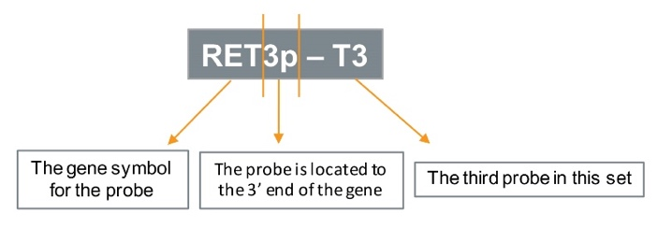Figure 1: Naming conventions for rearrangement probe genes provided in the HTG EdgeSeq ALK*Plus* Assay EU.

Table 1: Probes measuring the 5’ and 3’ ends of genes provided in the HTG EdgeSeq ALK*Plus* Assay EU.



**Fusion Junction Probes**

Often, a specific junction sequence appears in different samples, as exhibited by the prevalent EML4-ALK-v1 and v3 probes which constitute 70% of EML4 ALK rearrangement. When a specific junction site was frequently reported in public databases, a probe specific to the junction site was designed and included in the assay as shown in Table 2. The description and naming convention for these probes are detailed in Figure 2.

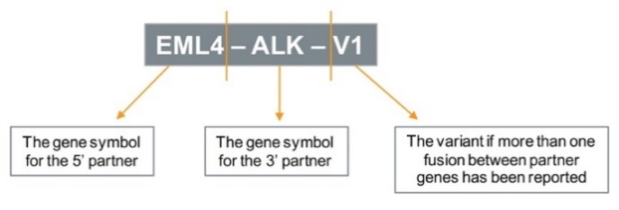

Figure 2: Naming conventions for fusion probe genes provided in the HTG EdgeSeq ALK*Plus* Assay EU.

Table 2: Fusion junction probes provided in the   
HTG EdgeSeq ALK*Plus* Assay EU.



**HER2 Exon 20 Insertion Probes**

Activating insertions into exon 20 of the ERBB2 (HER2) gene have been reported in several sources. Probes specific to the most commonly reported insertions are included in the assay and are designed to measure the presence of these sequences.

Table 3: HER2 Exon 20 insertion probes provided in the HTG EdgeSeq ALK*Plus* Assay EU.



**Miscellaneous Probes**

The Assay also contains a selection of probes that target the transcripts of common immunohistochemistry markers. The expression patterns of these genes may provide additional insight to the biology of these tumors.

Table 4: Miscellaneous probes provided in the   
HTG EdgeSeq ALK*Plus* Assay EU.



**Process Control Probes**

The Assay contains several sets of potentially useful process control probes as outlined below.

Table 5: Process control probes provided in the   
HTG EdgeSeq ALK*Plus* Assay EU.



The ANT series of probes target the AINTEGUMENTA gene found in Arabidopsis. The ER- series of probes correspond to specific transcripts within the ERCC RNA spike-in mix available for purchase separately from ThermoFisher Scientific (P/N 4456740).

Four positive process control probes (POS1 – POS4) are provided with complementary sequences in the probe mixture. These probes will be protected during the assay processing step and should be present in the sequencing data generated. The signals obtained from these probes will vary due to several factors, therefore, data from these probes should not be used for normalization or other quantitative assessments.

**Conclusion**

The HTG EdgeSeq ALK*Plus* Assay EU provides additional RUO content, including ROS1, RET, and NTRK1 fusion junction probes, that may be useful for researchers. Requiring only a single section of FFPE tissue, the Assay is a powerful tool for mutational analysis that preserves limited biopsy tissue for other research testing.

For more information, contact HTG Molecular Diagnostics, Inc. at 1-877-289-2615, [info@htgmolecular.com](mailto:info@htgmolecular.com) or contact your local HTG representative. Visit [www.htgmolecular.com](http://www.htgmolecular.com)

The Assay target sequences are available upon request (please contract info@htgmolecular.com).

1. Raw ALK expression data only available in RUO mode.
2. Illumina MiSeq may be used for CE-IVD version only.
3. The HTG EdgeSeq ALK*Plus* Assay EU contains data on 147 probes   
    which are accessible through the RUO login of the HTG Edge Host   
    Software. Please refer to the HTG EdgeSeq User Manual (CE-IVD) P/N   
    10309300 version B for the instruction to obtain these data.